Dear Friends of the Dominicans,
We are so thankful and grateful to God and you all for your great response to our “Covid19 Opportunity” emails! Our board of directors could never have imagined that this spring we’d be feeding over 1200 people daily via leaders that we have cultivated relationships with over the past 15 years!

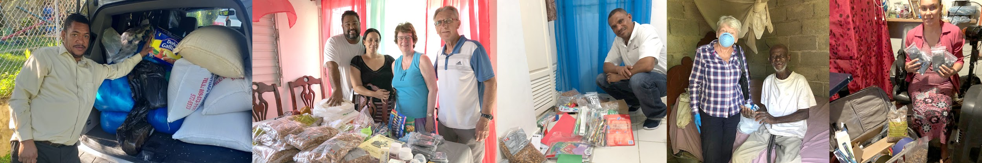
Pastor Chalas Pastor Winston & Katy Pastor Antonio Karen C. Pastora Morena
The D. R. government has helped some of these people a bit, but the vast majority of people we are involved with received little to no help. They are people who live from day to day on a bit of income that they scrounge from little bits of work, or selling fruit on the streets, cleaning people’s homes, washing clothes for others, etc. People who were employed in real jobs were expected to live on their savings. The country is starting to open up a little. At this time there is no tourism, which would normally provide tens of thousands of jobs.
Pastor Chalas has been making many trips to the bank, buying food for his community of about 250 people, packaging food with his family, and deliver our funds to our leaders we trust in other communities: Nego (Pastor Antonio) & Elsa feeding about 340 people, Karen C. feeding about 370 people, Pastor Winston & Katy feeding 100 people, Pastora Morena feeding about 240 people, plus 3 other leaders with minor amounts of food money. These leaders buy food in bulk, package & distribute to those most in need in their churches & communities. Items include rice, beans, sausage, tinned sardines, spaghetti, tomato paste, oil, seasonings & soap. Some include milk, buns.

FOOD DISTRIBUTION: Our cost has been less than $1.00 per day/person!
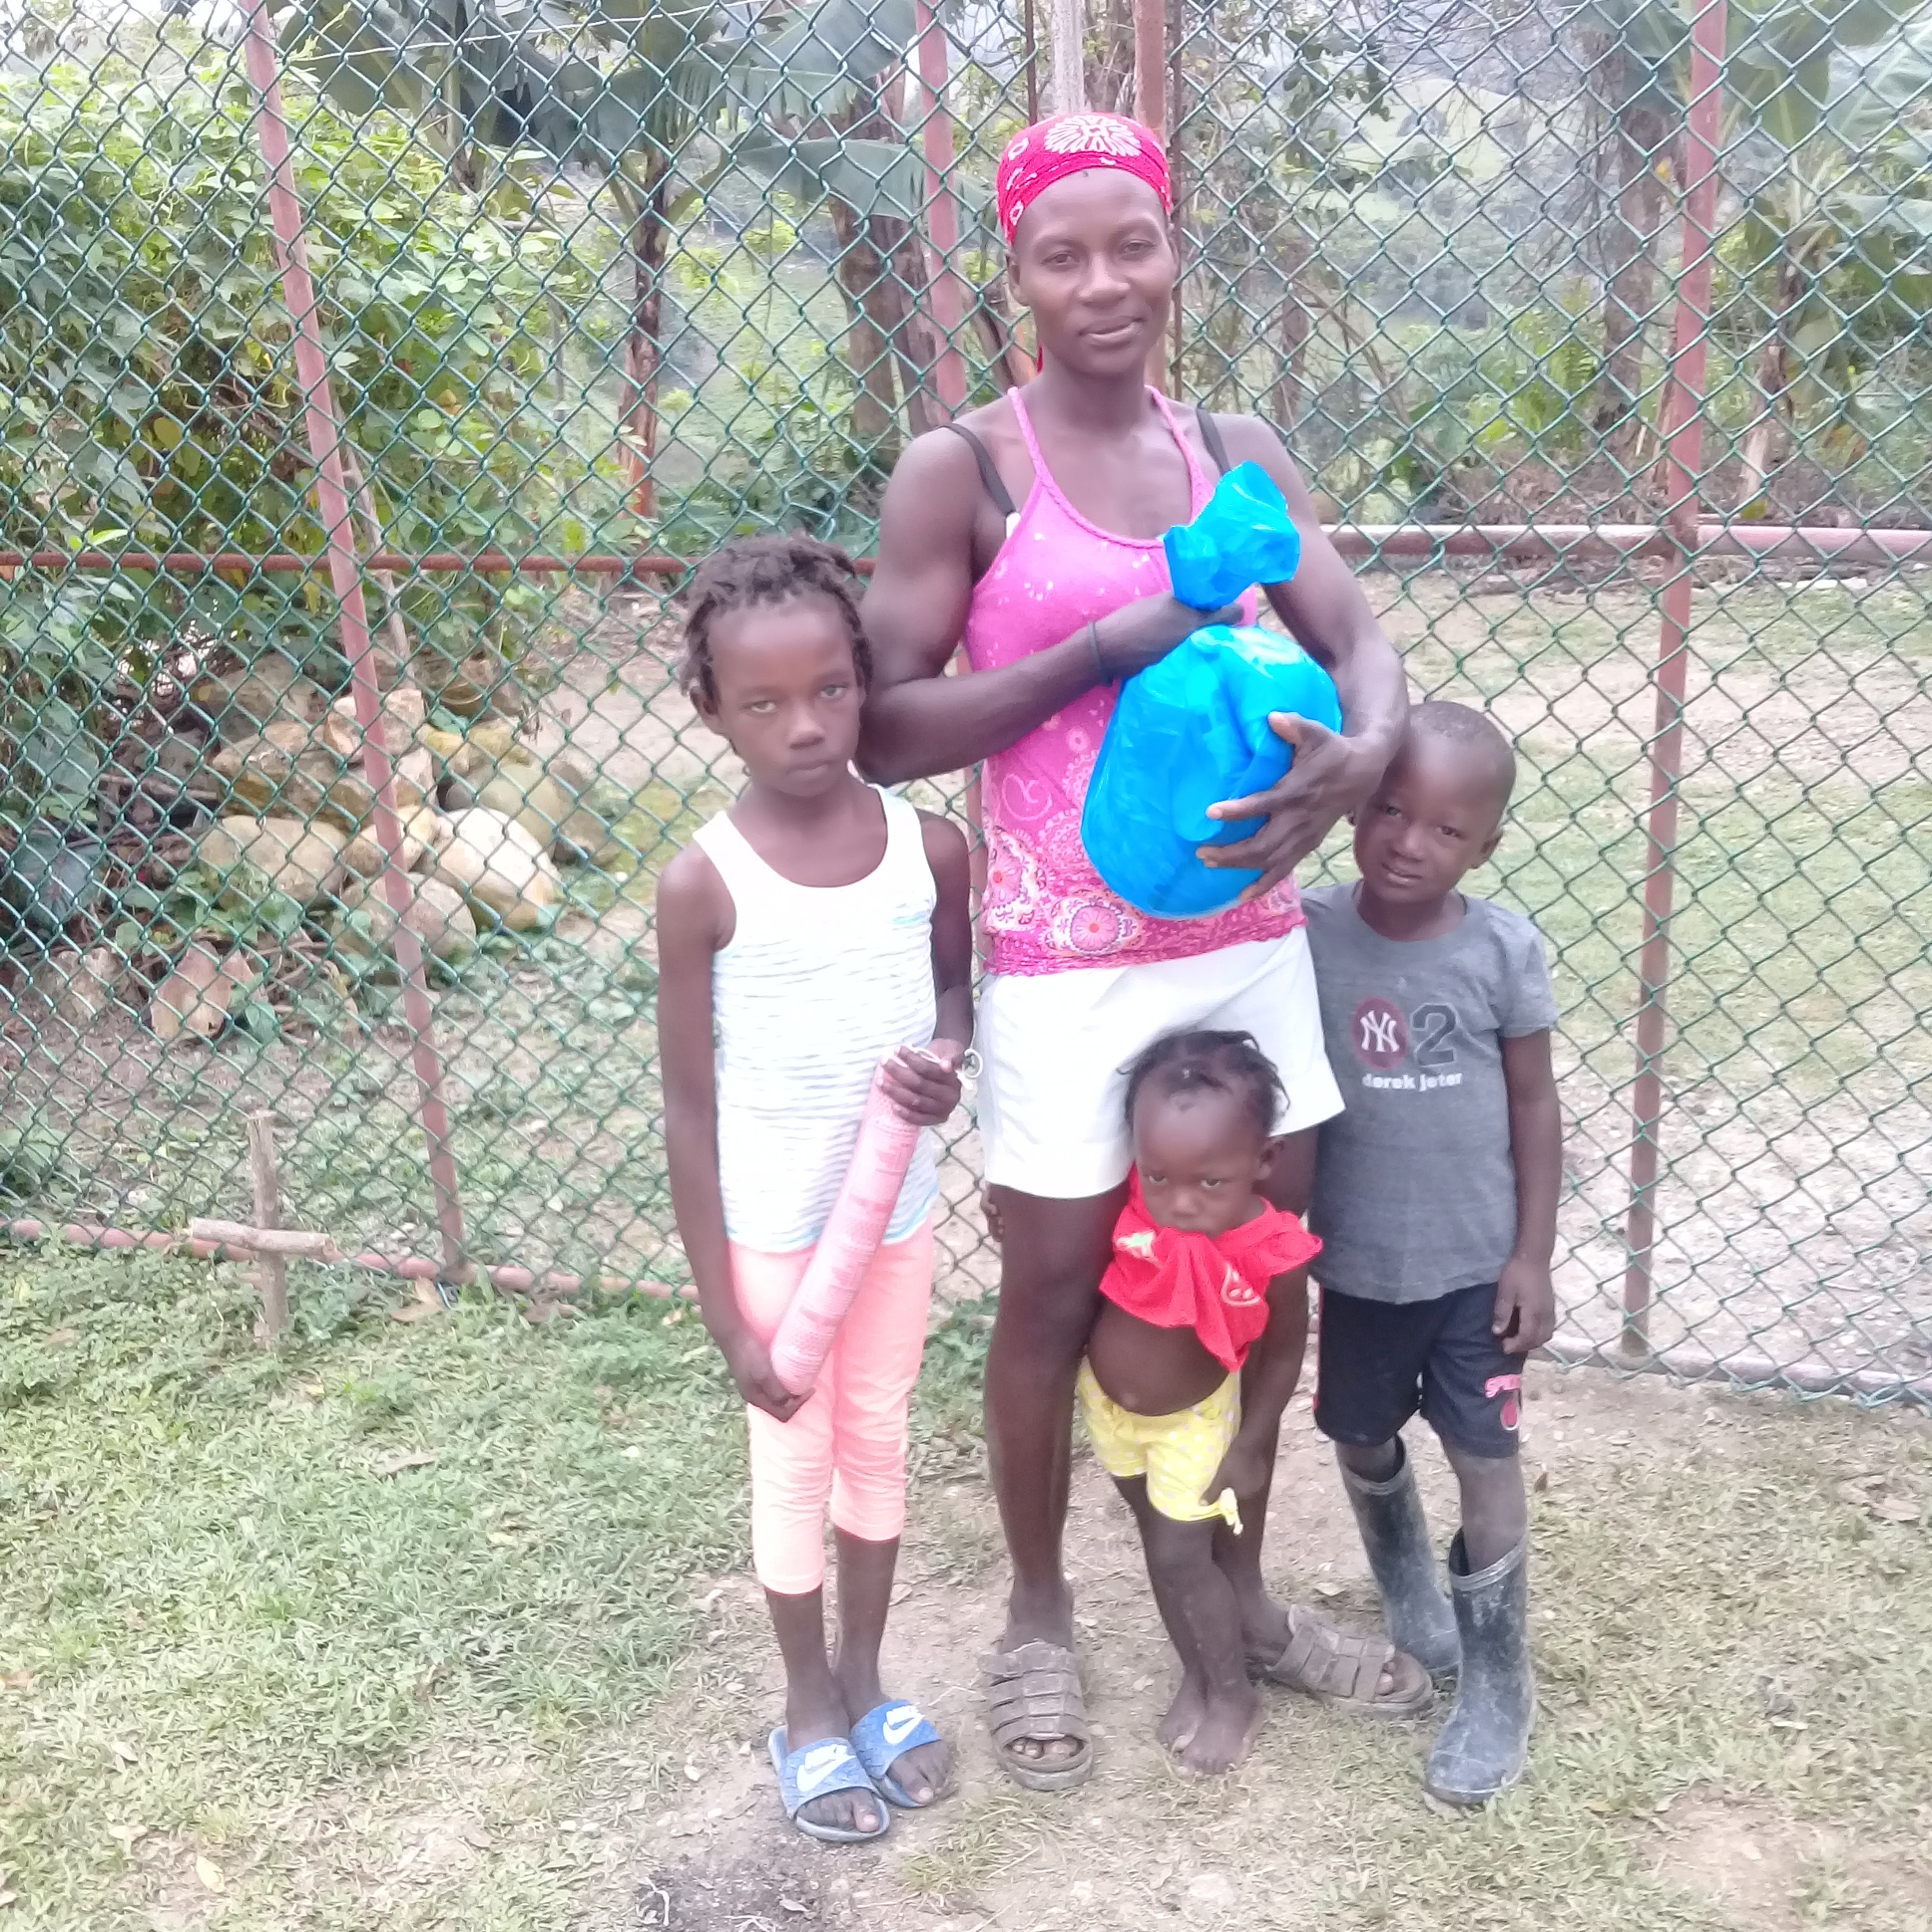
Winston came to this home of Ana and her family of 8. She explained that her husband and other kids were in the forest looking for food (they had no food in the house). This couple entrusted their lives to Jesus some months ago; besides food, they were given an MP3 Messenger with Spanish/Creole Bible on it. They saw the food from the Canadians as a gift from God!

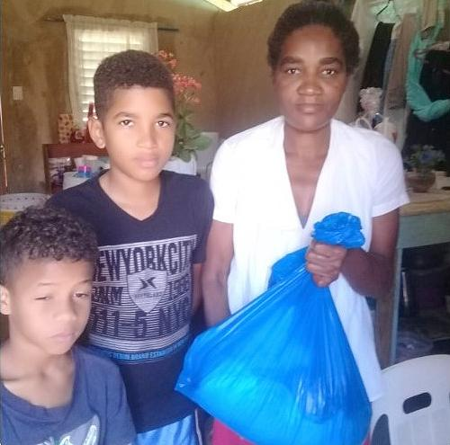
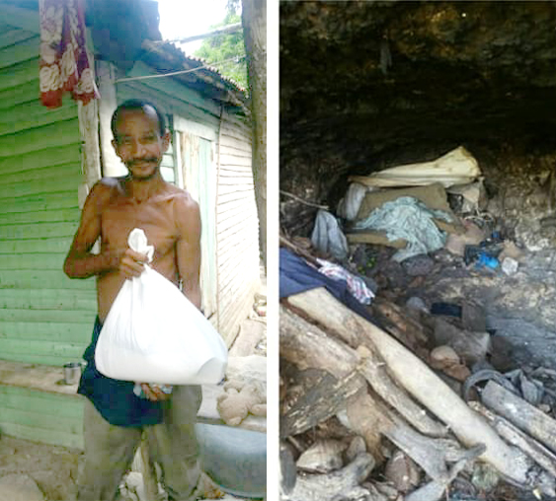
Winston and Katy were in 45 villages last year, bringing practical help such as dried veggie soup and apple chips from Canada, used clothes. They share about the love of Jesus and have Sunday School with the kids. They leave MP3 type players with Spanish/Creole Bible (from DVI) in these remote villages.

“A family had previously been given a Messenger MP3 with the Spanish/Creole Bible on it. When Winston and Katy arrived at their village, they came to meet them and said they had all become Christians listening to the audio Bible!”

“The people in a village told Winston about a man (picture 1 on left) living in a cave (picture 2 on left). His house had collapsed. As is the story with many people, there was no income and no food.”

“This woman had one cup of rice left for her and her children. She was praying to God for help. That is when Winston arrived with the hamper of food. She praised God for this!” (picture on left)
OTHER NEWS
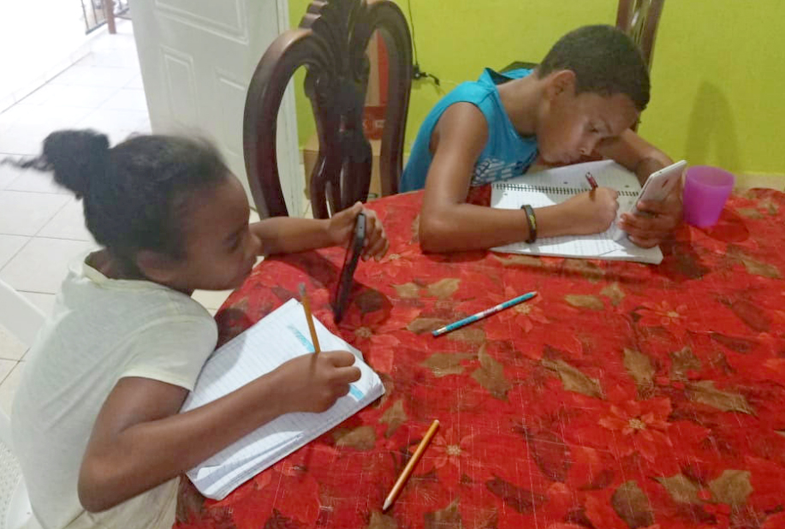
Colegio Cristiana Divina Misión

School in Arroyo Seco – has been closed since end of March. The teachers are sending homework with the food packages. Internet learning is not possible as almost no one has a computer. School is over first week in June and resumes mid- August. Each week the pastor brings new homework and food to students and teachers come and correct work twice a week.
Picture on left - Children grade 4 and 6 doing homework

GARAGE SALE. AUGUST 21-22 (tentatively) Call or text Walter 204-298-1297.

LEADER TEACHING RETREAT. Postponed to spring 2021.

ONLINE UPDATES:

DVI website has been updated
www.dominicanvision.org

Dominican Vision Facebook Group is now public.

PRAISE REPORT:

The number of people needing help is increasing and we don’t know how long we need to continue with food distribution!

We would appreciate continued financial support throughout this crisis to enable us to continue serving those in need. Please pray for the pastors that they stay safe from the virus when purchasing and delivering food, and for physical safety for protection from theft.
Thank you so much for your prayers and donations! May God bless you richly!
Walter and Carol Warkentin, Betty Giesbrecht, Ted and Esther Wogberg, Pastor Hipolito Chalas

